**DATABASE FINAL PROJECT**

**PHASE 2**

**CONTENT:**

1. **ERD DIAGRAM:**

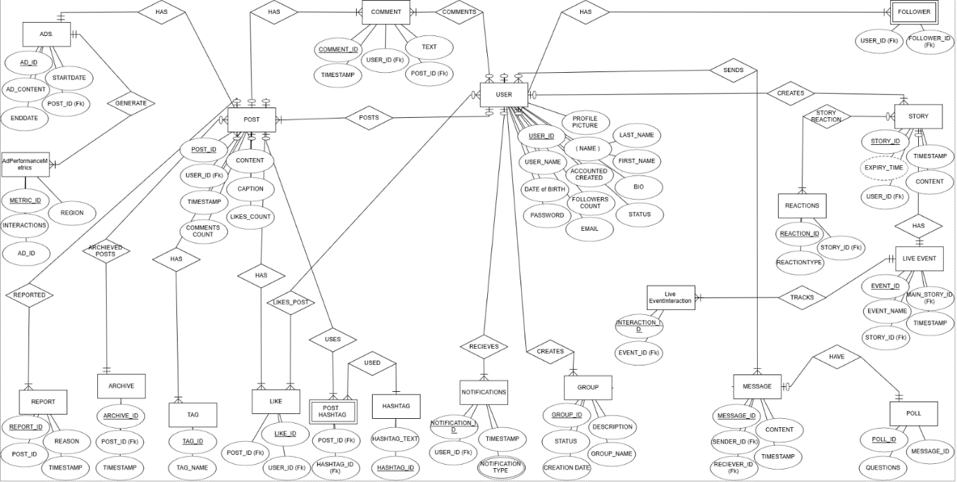

1. **RELATIONAL SCHEEMA:**

